Save the Date!

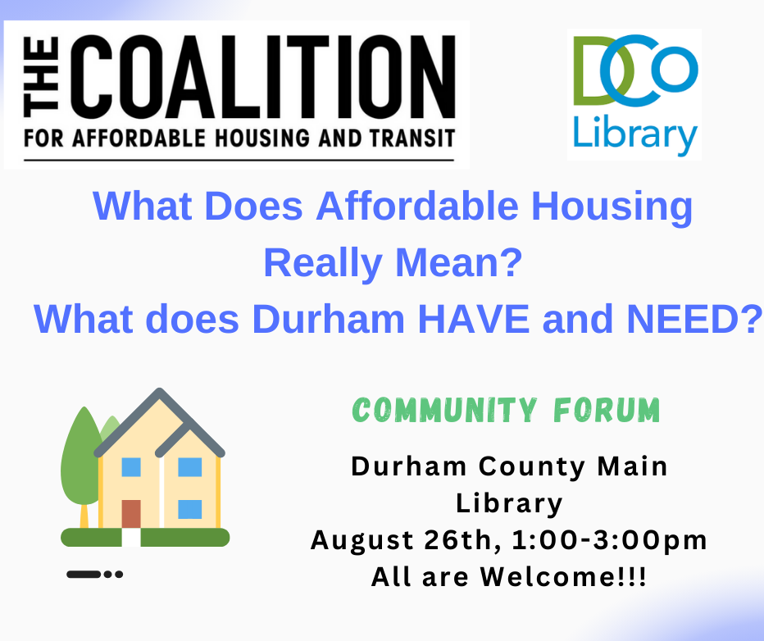

The Coalition for Affordable Housing (CAHT) is holding a public forum on the real meaning of “affordable housing” and housing affordability for Durham residents on Saturday, August 26th, from 1:00 – 3:00 PM. Speakers will discuss topics such as Area Median Income (AMI), Durham’s current housing market, the city’s status in providing affordable housing, Durham’s history of racial discrimination in housing, and so much more. The event aims to provide a common language to communicate housing needs to city officials and real estate developers.

Representatives from over forty organizations working on Durham’s affordable housing crisis are encouraged to attend. The event is also open to Durham citizens and other interested parties within the community.

Register today; seats at the event are going fast. We hope to see you there!

